Day in the Life of the Hudson River 10/14/21
SWINDLER COVE, MANHATTAN
RIVER MILE: 13
Salt Front: ~ RM 49
Dos Puentes Elementary School- Queila Cordero and 6 adults
60 students, 5th grade
NYS DEC- Chris Bowser, Jesenia Laureano
Latitude 40.85784 N & Longitude – 73.92201 W
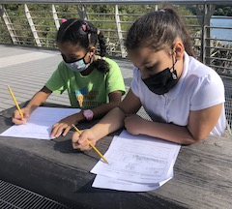 | 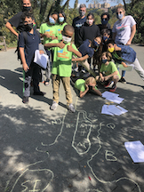 | 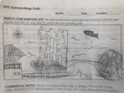  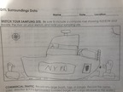

Location: Beach at Swindler Cove Park, next to the north end of Harlem River Drive, Manhattan
Area: There is a pier, beach, floating boathouse with a dock. Area used for boating, rowing, biking, walking, school groups- forested and grassy area
Surrounding Land Use: 50% beach, 50% Industrial/Commercial
Sampling Site: Sandy, muddy beach area, covered with vegetation, riprap banks
Plants in area: grass, sycamore trees
Water depth:
River Bottom: muddy

ITEM | Time | Reading |  |  | Comments
Physical
Air Temperature | NA
Wind Speed: | NA
Weather today | NA
Weather the past 3 days:
Water Temperature- collected from bucket | 10:27AM  11:30 AM  12:26 PM  1:00 PM | 20.83 º C  21.94 º C  21.11 º C  22.22 º C | 69.5 º F  71.5 º F  70 º F  72 º F
Turbidity- Long sight tube | Throughout day | Avg: 31 cm
Chemical
Salinity- Hydrometer | 10:27AM  11:30 AM  12:26 PM  1:00 PM | 18 ppt  18 ppt  18 ppt  20 ppt
DO – | Time | Temp | ppm DO |  | % saturation
 | 10:27AM  11:30 AM  12:26 PM  1:00 PM | 20.83 º C  21.94 º C  21.11 º C  22.22 º C | 6 ppm  5+ppm  5 ppm  7 ppm
pH – | NA
Biological
Fish | Number | Name | Length of longest |  | Length of smallest
 | 76  4 | Mummichog  Atlantic Silverside
Fish Totals | TOTAL: 80 | Diversity: 2
Macroinvertebrates | Number | Name | Length of longest |  | Length of smallest
 | 1  4  4 | Blue Crab  Ctenaphore  Brine shrimp
Macroinvertebrate Totals | TOTAL: 9 | Diversity: 3

